**Project Step 14 - Sprint Execution And Review**

**Caleb Pleasant**

Sprint Execution And Review

Correctly planning and executing to a sprint plan is essential to tracking progress for the agile software development process. Product Backlog Items (PBIs) may be sourced from internal as well as external stakeholders but backlog grooming is the product owner's responsibility. The scrum team commits to how many of the highest priority items that they can accomplish during the sprint and, as a team, completes those items one-by-one. At the end of the sprint, the scrum team presents their results to the stakeholders for feedback, project support, and potential requirements change.

This week, execute to your project list, each day moving items from your todo list, to Work-in-progress (WIP) and finally to 'complete'.

**Submit: 1.) Daily screenshots Each day take a screenshot of the Kanban issue board. At the end of the sprint, submit your daily screenshots.**

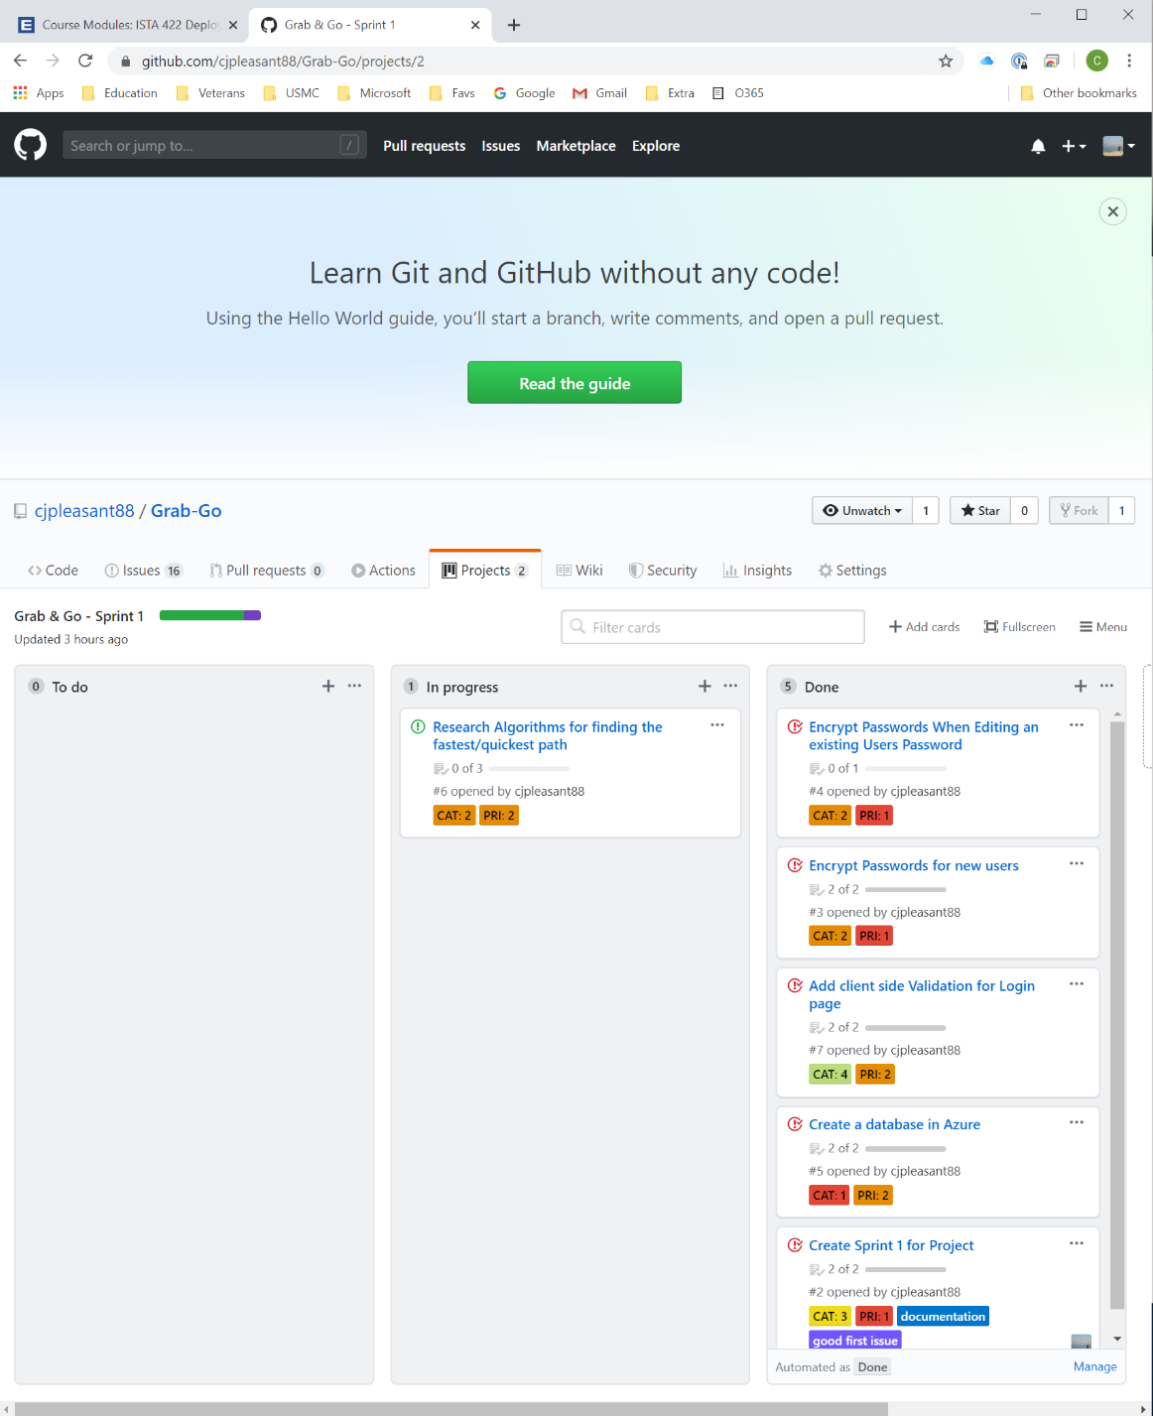

This progress was done at the beginning of the week and where the deliverable progress stopped. This is the only screen shot due to no changes throughout the week, research, and data model changes.

**2.) Burndown chart (what is a burndown chart?) There are many sprint tracking tools available. Github is convenient because you can track all elements of your project together, but it doesn't support burndown charts yet. Use any tool to show what a burndown chart of your sprint might look like.**

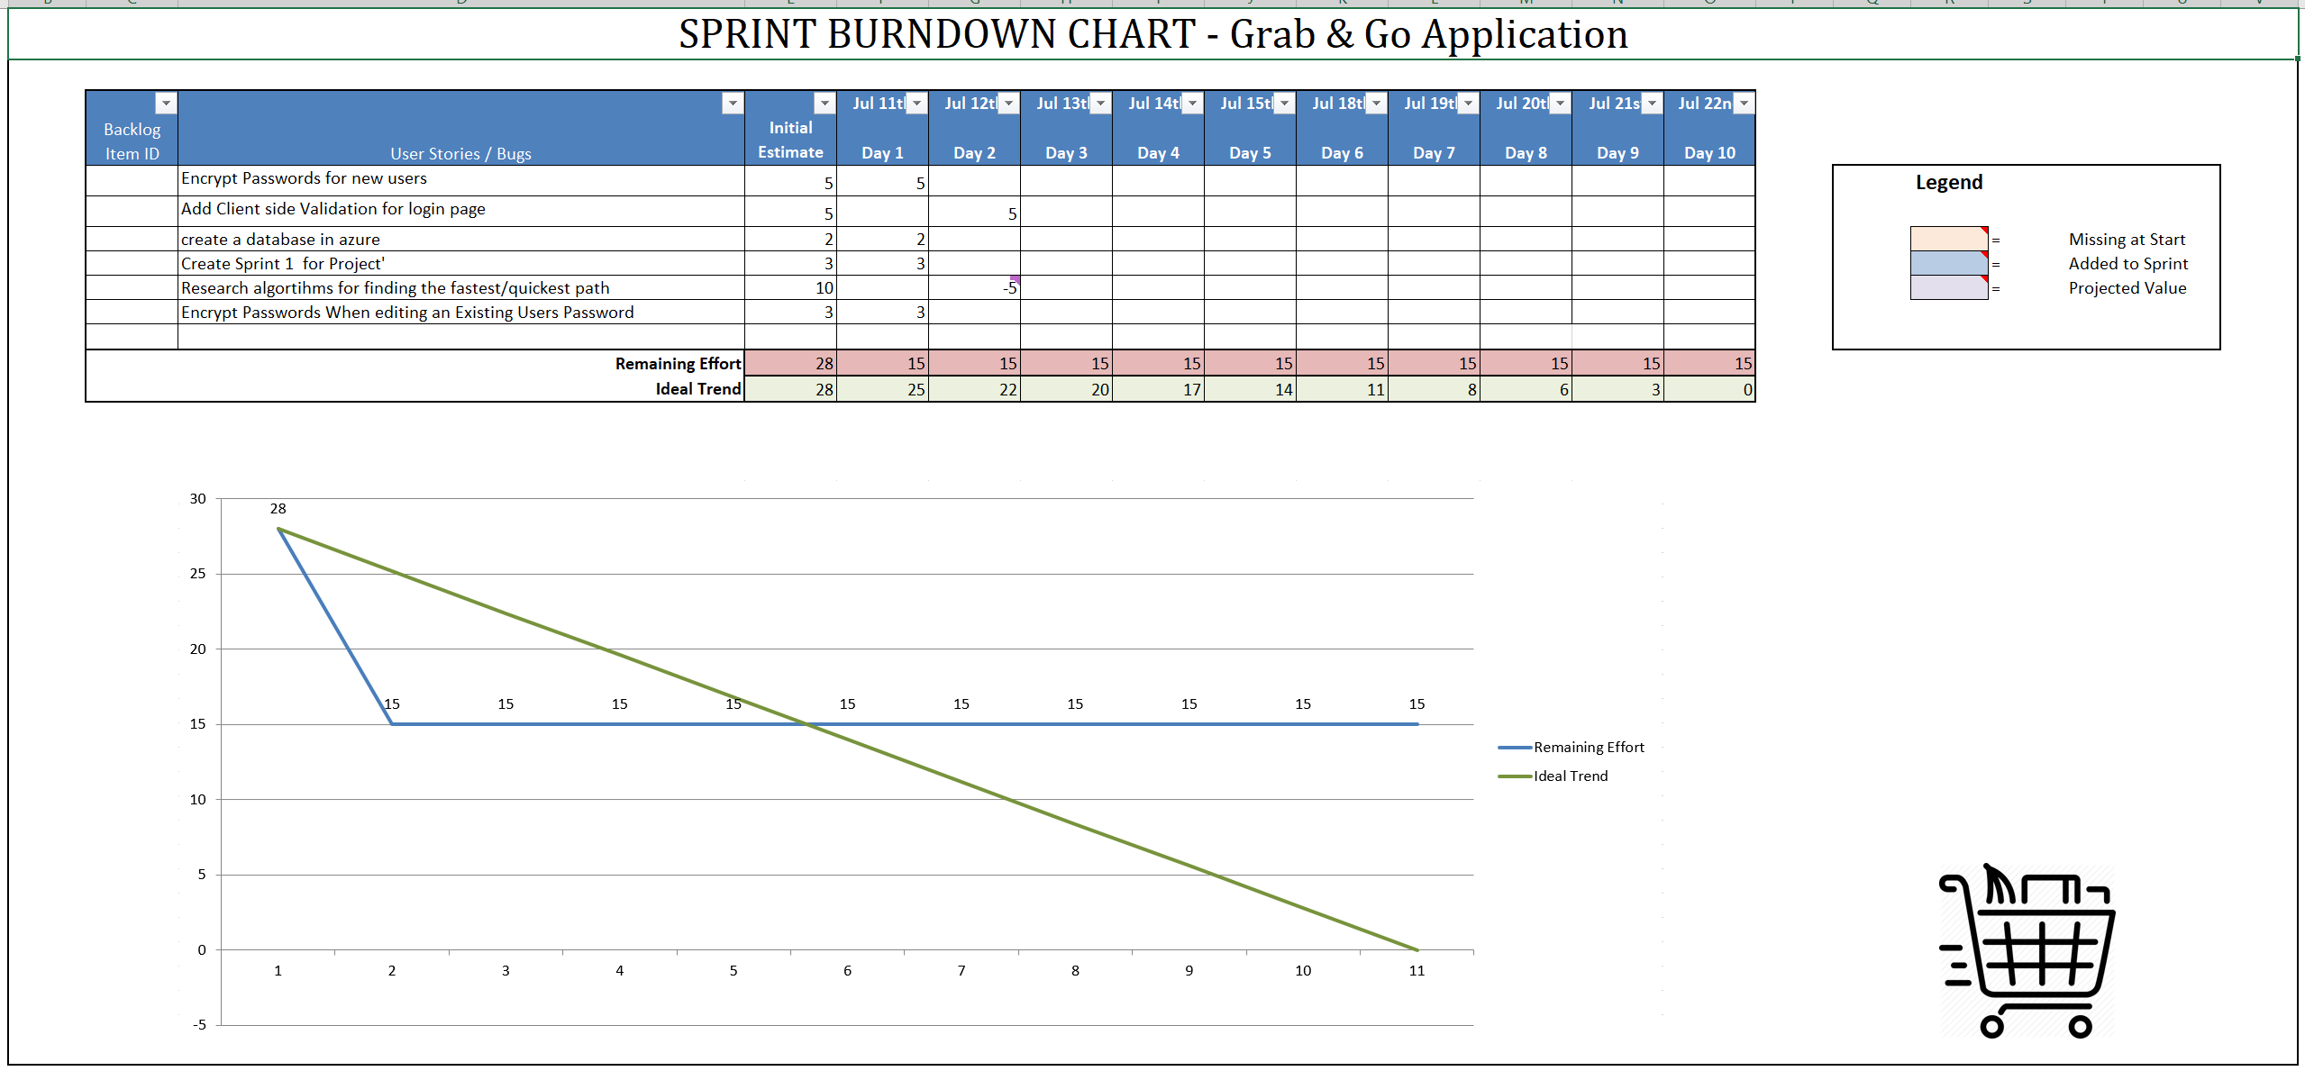

Looking into ZenHub as a GitHub Extension for Burndown Charts. A fellow student in the class shared a good resource for explaining Burndown charts which had template that was utilized for the above screenshot. The screen shot very clearly shows the appearance of no progress due to data model changing and research.

**3.) Sprint Review Answer the following:**

* **Did you complete all items in your sprint plan?**

I did not complete all of the items, one is remaining. I am still researching the best way to manipulate the data to show the best path for a customized list of items in any custom store layout. Since this is what the concept of the application revolves around, it is taking longer to narrow down as I am changing some of the data models.

* **What is your sprint deliverable? (shippable product(s))**

As of right now, The application:

* + displays the main/starting page any user will first experience
  + Ability to create an account in the database
  + Ensure that passwords are stored encrypted in the database
  + Sign in if an account already exists
  + Error pages and data entry validation is also included on these pages
  + Displays a non-persistent Shopping list utilizing javascript once signed in for demonstration purposes
* **Did you have any task volatility, and what was the cause?**

I did add one task, encryption needs to be on account creation as well as when a user/admin edits account details at a later time after account creation.

* **What would you do differently knowing what you know now?**

Planning data models in greater detail would of sped up the process. I, from a progress stand point, feel like not much was done due to time researching and data model changes.

**4.) (Next) Sprint Plan Create another 'project' (may be named "sprint 2") and add items from your prioritized backlog issues. Attach a screenshot of the new Kanban board (sprint plan)**

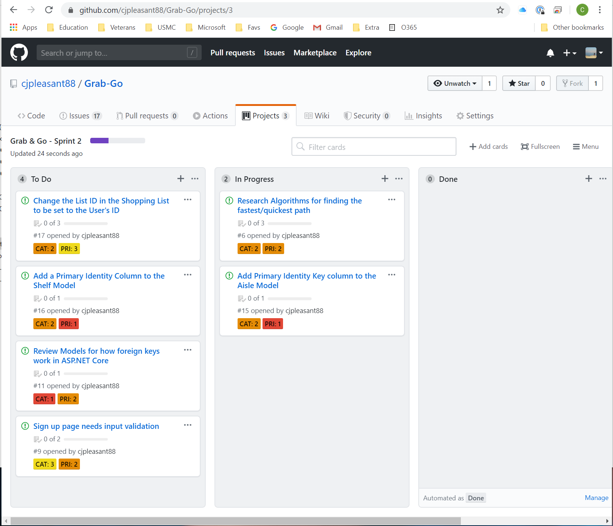

Moved the uncompleted item from sprint 1 to this weeks board.